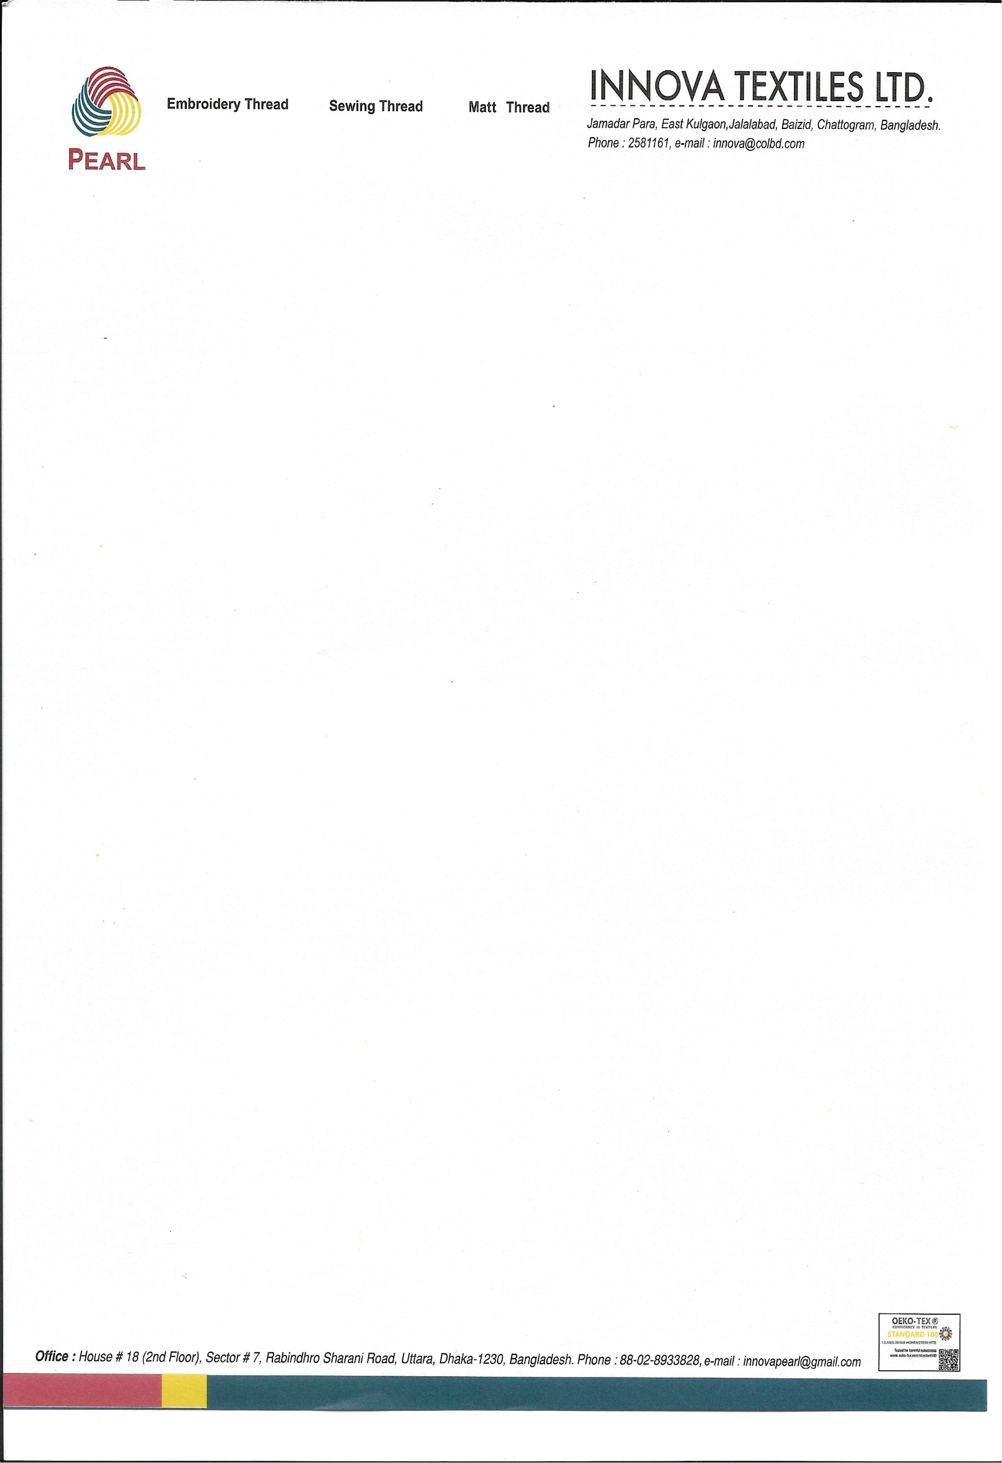

June 04, 2026

To Whom It May Concern

This is to certify that Ms. Nameera Nawar, daughter of S. M. Murad, is currently employed as a Welfare & Community Engagement Executive at Innova Textiles Ltd. She joined the organization on March 7, 2023, and continues to serve in this position with dedication and professionalism.
In her current role, Ms. Nawar plays a key role in designing and implementing employee well-being programs, community outreach initiatives, and social development activities across the factory premises. She consistently demonstrates sincerity, honesty, and commitment in carrying out her responsibilities. She is hardworking, professional, and possesses strong work ethics along with excellent operational knowledge. Her pleasant personality and commendable character have made her a valued member of our team.
Ms. Nawar currently receives a monthly salary of BDT 30,000 (Bangladeshi Taka Thirty Thousand Only), which is paid in cash in accordance with company policy.
We highly appreciate her valuable contributions to the organization and are confident that she will continue to excel in her professional endeavors.

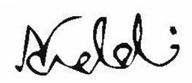
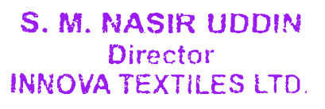

S.M. Nasir Uddin
Director
Cell: +880 1730055510
E-mail: nasir.uddin@innovatextiles.co

